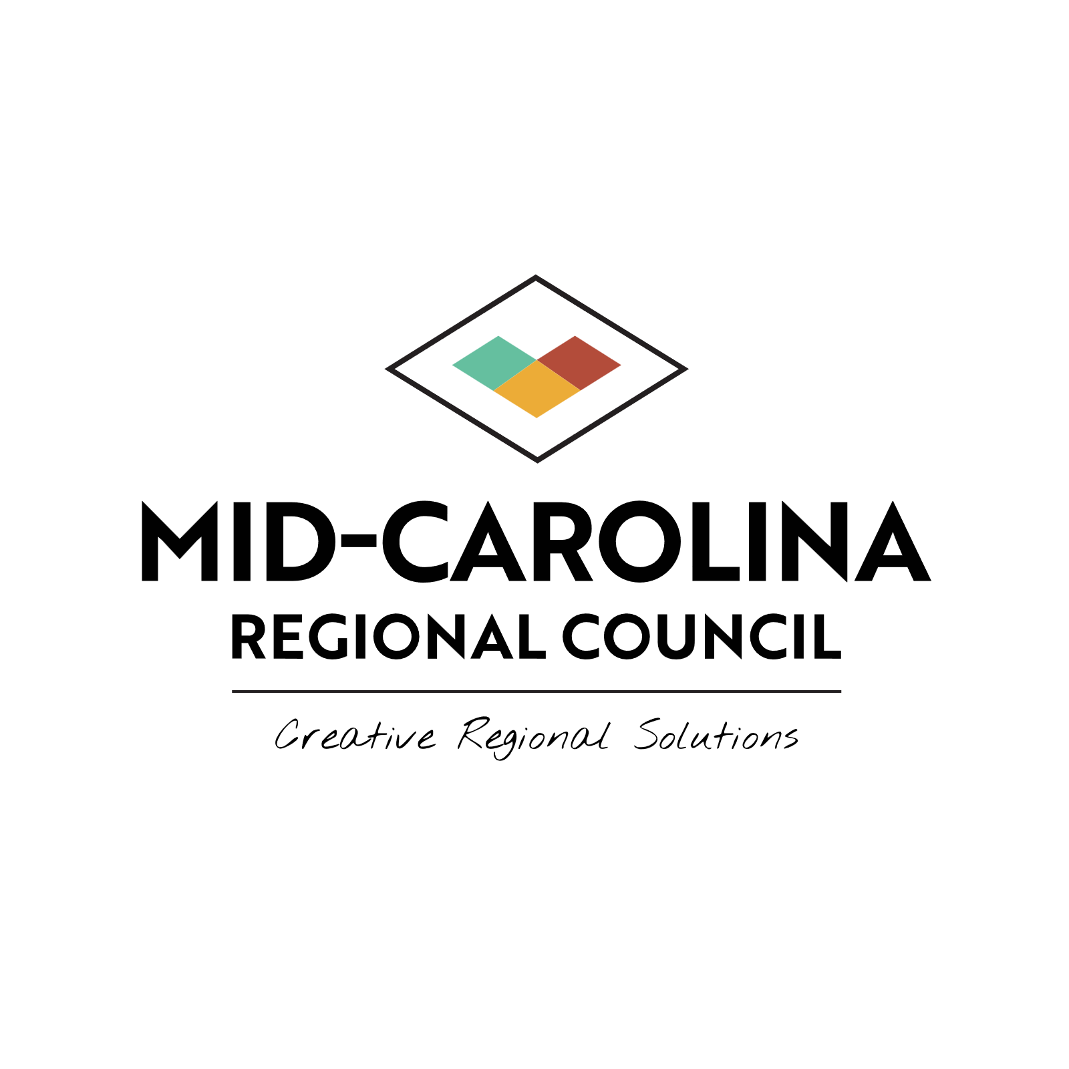

**Mid-Carolina Regional Council Board of Directors**

**Meeting Notice**

The Mid-Carolina Regional Council Board of Directors will meet at 12noon on Thursday, August 28, 2025 at City of Dunn City Hall located at 401 E. Broad St. Dunn, NC 28334.

Persons may elect to participate in the meeting remotely through Zoom. Zoom log-information is as follows:

Topic: Mid-Carolina Board of Directors August Meeting

Time: August 28, 2025 12:00 PM Eastern Time (US and Canada)

Join Zoom Meeting

<https://zoom.us/j/93496888316?pwd=qgyr2BiFyEhVih6X3q1FwgOI7FNu3N.1>

Meeting ID: 934 9688 8316

Passcode: 653950

One tap mobile

+16469313860,,93496888316#,,,,*653950# US

+19292056099,,93496888316#,,,,*653950# US (New York)

Dial by your location

• +1 646 931 3860 US

• +1 929 205 6099 US (New York)

• +1 301 715 8592 US (Washington DC)

• +1 305 224 1968 US

• +1 309 205 3325 US

• +1 312 626 6799 US (Chicago)

• +1 386 347 5053 US

• +1 507 473 4847 US

• +1 564 217 2000 US

• +1 669 444 9171 US

• +1 669 900 6833 US (San Jose)

• +1 689 278 1000 US

• +1 719 359 4580 US

• +1 253 205 0468 US

• +1 253 215 8782 US (Tacoma)

• +1 346 248 7799 US (Houston)

• +1 360 209 5623 US

Meeting ID: 934 9688 8316

Passcode: 653950

Find your local number: https://zoom.us/u/aw8vHsVpn