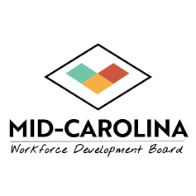
MID-CAROLINA WORKFORCE DEVELOPMENT
CHIEF ELECTED OFFICIALS BOARD
MEETING NOTICE

Notice is hereby given that the Mid-Carolina Workforce Development Chief Elected Officials Board will hold a special meeting at 12 pm on Wednesday, April 1, 2026. This meeting will be held virtually as permitted by North Carolina law and the Chief Elected Officials Board’s Bylaws.

Those wishing to attend the meeting may participate through Zoom. Zoom log-information is as follows:

Topic: Mid-Carolina Workforce CEOB Meeting

Time: April 1, 2026, 12:00 PM Eastern Time (US and Canada)

Join Zoom Meeting
https://zoom.us/j/98194055243?pwd=aq0N6WrpMNAEaYRb4gA87EbxAi9X3L.1
Meeting ID: 981 9405 5243
Passcode: 252346
---
One tap mobile
+13052241968,,98194055243#,,,,*252346# US
+13092053325,,98194055243#,,,,*252346# US
Join instructions
https://zoom.us/meetings/98194055243/invitations?signature=YNYOQpP9II_1hvghFKU_VdFlDvPpJcPrTKQpwNAghgg
──────────

