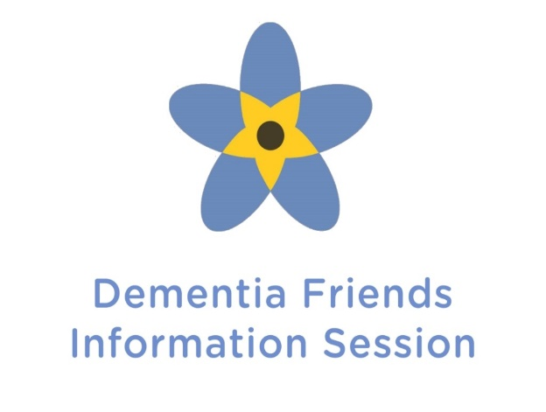
Dementia Friends
North Carolina
A Dementia Friendly America Initiative
HELP CREATE A
DEMENTIA FRIENDLY
COMMUNITY

Come to a Dementia Friends Information Session to learn a little about what it is like to live with dementia and turn that understanding into action.
Anyone of any age can become a Dementia Friend. You will learn more about dementia and how you can help Cumberland, Harnett, and Sampson counties become dementia-friendly communities.
Thursday, February 19, 2026
10:00 am – 12:00 pm
Senior Center East
917 Washington Drive, Fayetteville NC 28301


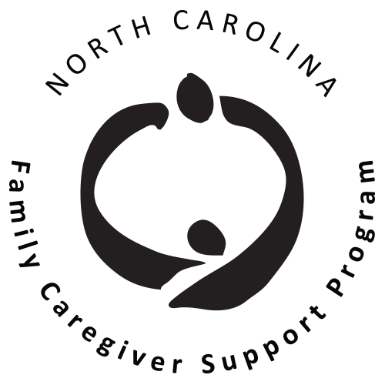
To RSVP & For More Info:
Barbara A. White
910-323-4191 ext. 28
bwhite@mccog.org

Paige Jasper
910-433-1574
paigejasper@fayettevillenc.gov

